
Kyle's
Math Drill
Version 1.1, October 2008

You are welcome to freely copy and use this software. It was created by Kyle Cordes at Oasis Digital Solutions Inc., to help his kids practice basic arithmetic facts. It is intentionally very simple, with nothing to distract from the problems at hand.

You can reach Kyle at http://kylecordes.com

Installation
Run the installation program, “MathDrillSetup.exe”, then follow the prompts. You can uninstall the software normally in the Control Panel, Add/Remove Programs screen.

Operation
When you run the software (from its icon on the the Start menu), you first see the setup screen:

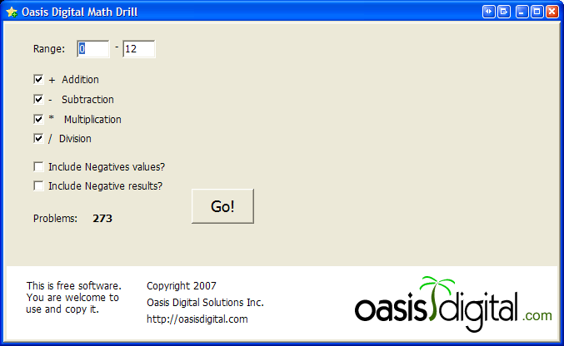 | From here you can set:  - The range of values used (for example, numbers 1 though 10, 0 through 12, etc.  - Which operations to include  - Whether to include negative numbers in the problems and/or the answers  Then click “Go!”, to move on to the screen below.
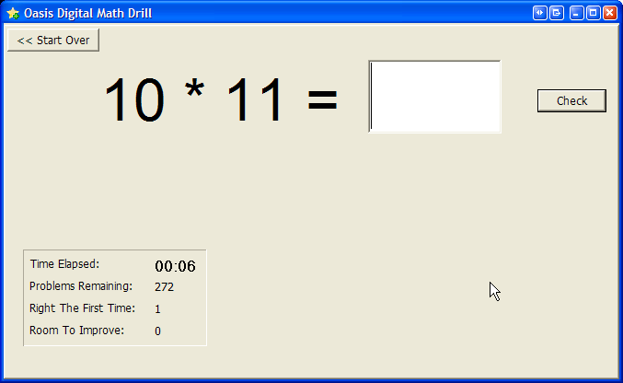 | Answer each problem by typing the number then clicking “Check” or pressing the Enter key.  The software will track how many problems you got right, how many you got wrong, how long you have spent, and how many problems remain.  If you answer incorrectly, the same problem will be presented again later; so that you can practice until you get them all right.

The goal of this software is to enable practice, not to assess or score; that is why there is no percentage correct or “grading” feature.

